1. Write a program to check whether the given character is an uppercase letter or lowercase letter or a digit or a special character.

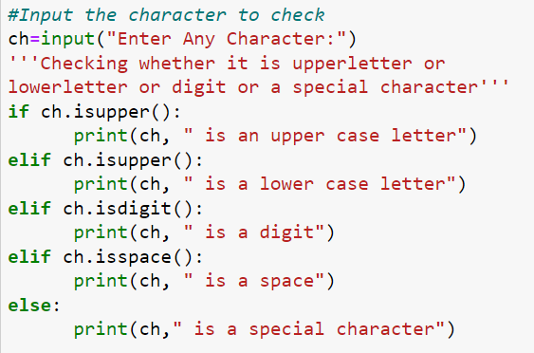

2. Write a program to find the maximum number out of the given three numbers.

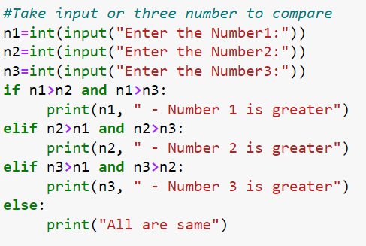

3. An electric power distribution company charges its domestic consumers as follows  
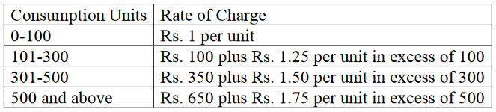

Write a program that read the customer number & power consumed and prints the amount to be paid by the customer. Note that output should be well formatted.

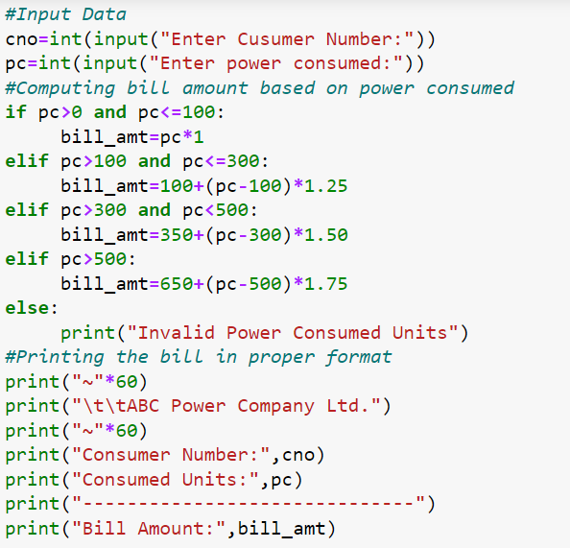

4.Write a program to create a list of students' marks with user-defined values and find the maximum.

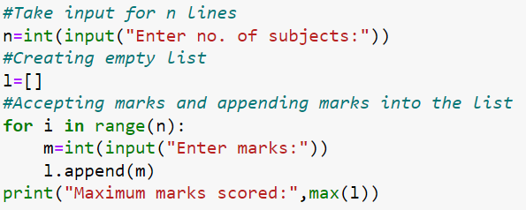

5. Write a program to create a list of numbers and swap the content with the next value divisible by 5.  
For example: list = [4,25,31,7,35,44,55]  
Output: [25,4,31,35,7,55,44]

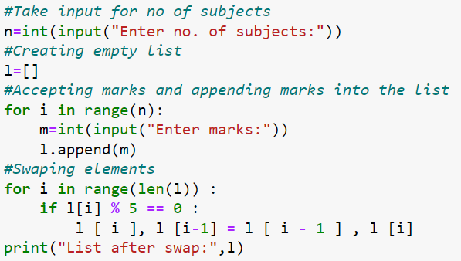

6. Write a program to generate the following pattern.

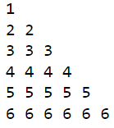

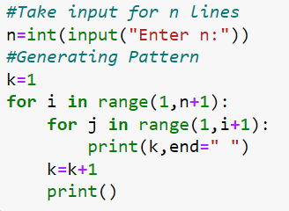

Unit 4 Data Science Programs

7.Write a program to create a 1D array using NumPy.

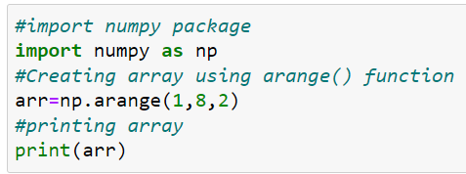

8. Write a program to convert a python list to a NumPy array.

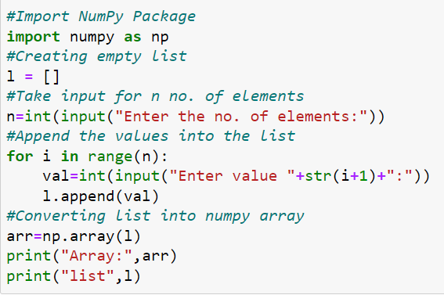

9. Write a program to develop a matrix of 3x3 with values from 21 to 38.

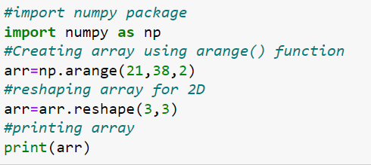

10. Write a program to represent the data on the ratings of mobile games on bar chart. The sample data is given as: Pubg, FreeFire, MineCraft, GTA-V, Call of duty, FIFA 22. The rating for each game is as: 4.5,4.8,4.7,4.6,4.1,4.3.

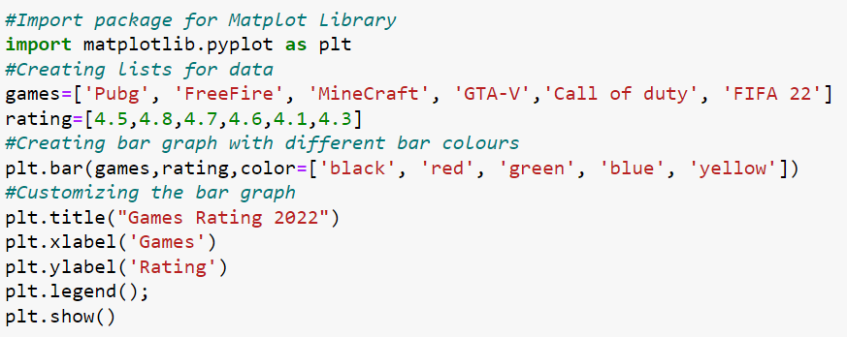



11. Consider the following data of a clothes store and plot the data on the line chart:

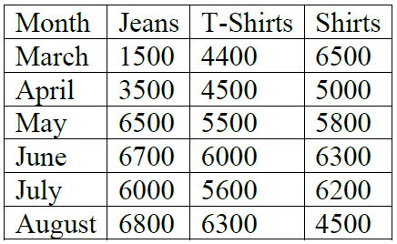

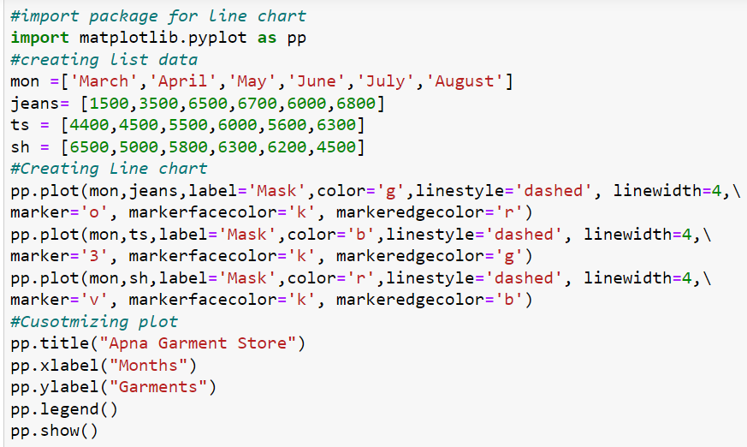



12. Observe the given data for monthly sales of one of the salesmen for 6 months. Plot them on the line chart.

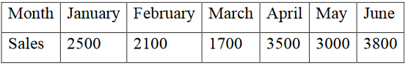

Apply the following customizations to the chart:  
• Give the title for the chart - "Sales Stats"  
• Use the "Month" label for X-Axis and "Sales" for Y-Axis.  
• Display legends.  
• Use dashed lines with the width 5 point.  
• Use red color for the line.  
• Use dot marker with blue edge color and black fill color.

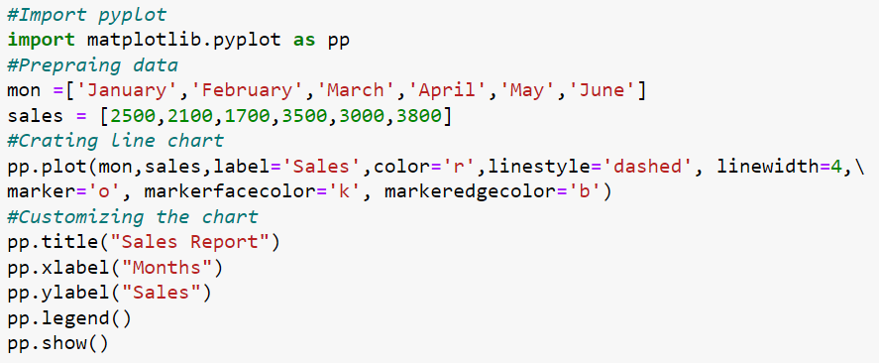

**Data Science Practical (Pie Chart)**

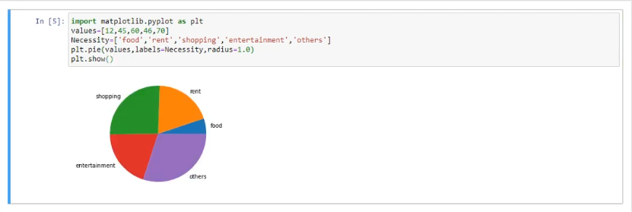

**F use for complete floating no.**

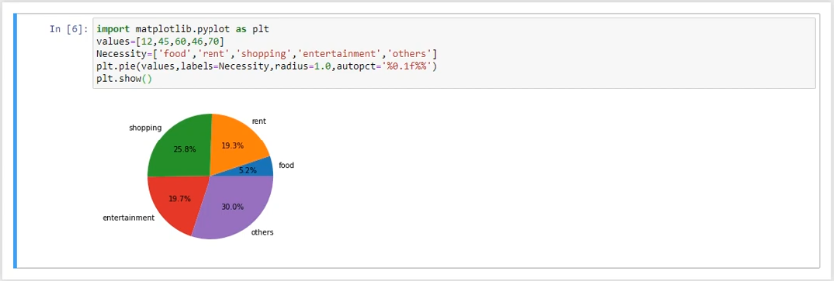

**D use for complete no.**

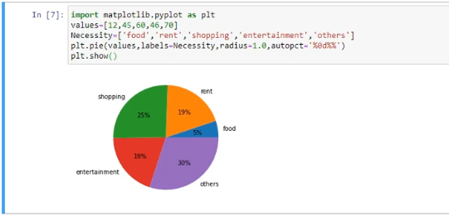

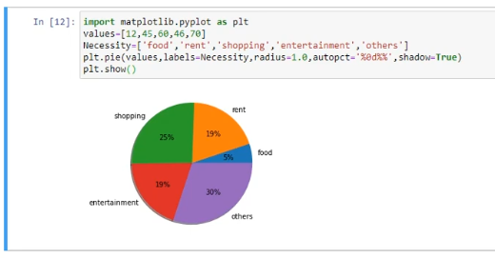

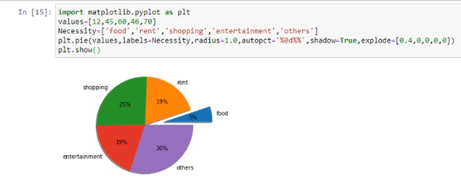

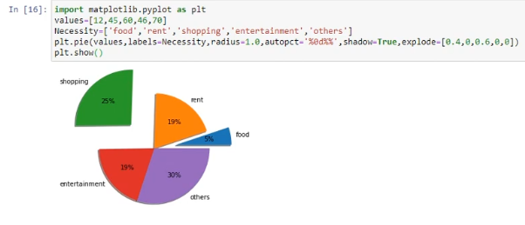

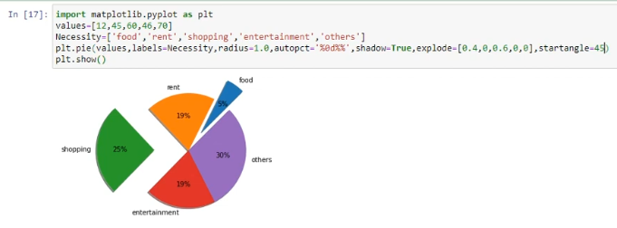

# Data Science Practical’s (Histogram Plot)

# 

# Attribute: rwidth=0.8

# 

# Function: xticks(age_group)

# 

# Function: yticks(range(0,9,1))

# 

# Data science, Scatter plot (Practical)

# 

# Boxplot Chart

# 

# For multiple boxplot

# 

# Computer vision practical

# Q. how to insert image in jupyter notebook

# Method 1

Step 1. Go to code section and select the **Markdown**

Step2. Click on edit and click on **insert image** option and ask to you select image and choose an image. And choose file and ok.



Step3. Click on run button.



Method 2

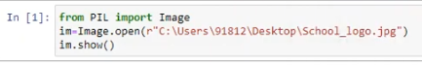



Resolution of image

Q. To find out the height and width of an image.

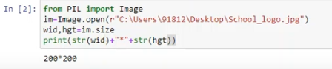

Method 2

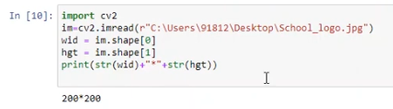

# Image segmentation

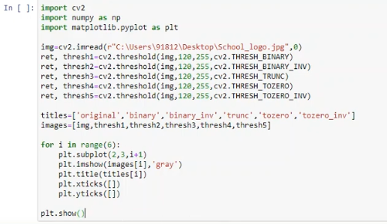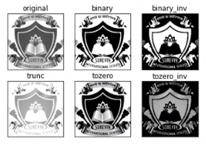

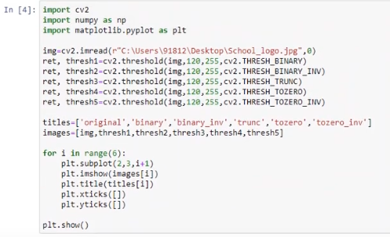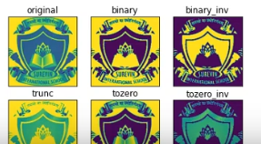

# pixel value

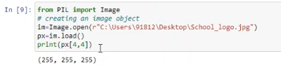

If px[4,4]=(0,0,0)

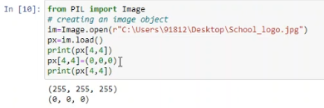

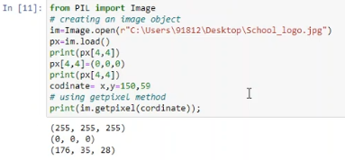

# RGB images (show original image)

# 

# Gray_image: convert color

# 

# Method 2: if set 1 then original image and set 0 then grayscale image

# 

